**Lab – Hashing Things Out**

Ashkeyev Ali 18BD11079

**Objectives**

Part 1: Creating Hashes with OpenSSL

Part 2: Verifying Hashes

**Part 1: Creating Hashes with OpenSSL**

OpenSSL can be used as a standalone tool for hashing. To create a hash of a text file, follow the steps below:

Step 1: Hashing a Text File

1. The hash will be displayed on the screen after OpenSSL has computed it.

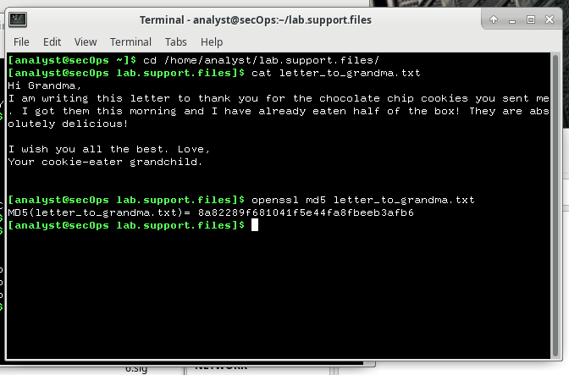

1. Modified file hash

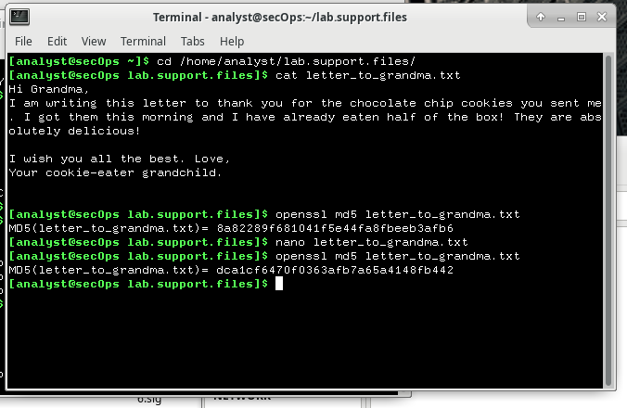

**Is the new hash different that hash calculated in item (d)? How different?**

Yes, hash of modified file is different. It indicates integrity of file.

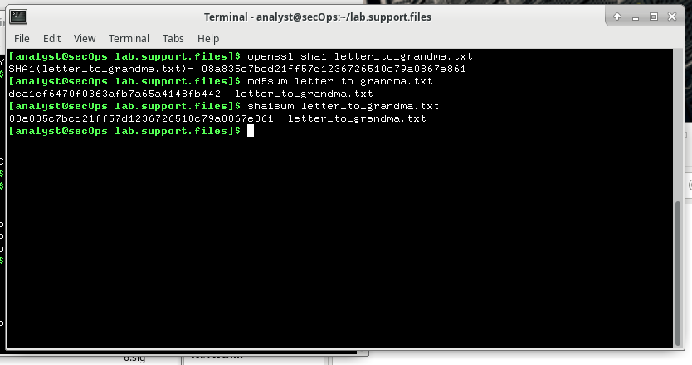

**Do the hashes generated with md5sumandsha1sum match the images generated in items (g) and (h), respectively? Explain.**

Yes, algorithm methods in g and h are different, but input data and algorithm are the same with in image and in terminal. That’s why my hashes are math with the hashes in image.

**Part 2: Verifying Hashes**

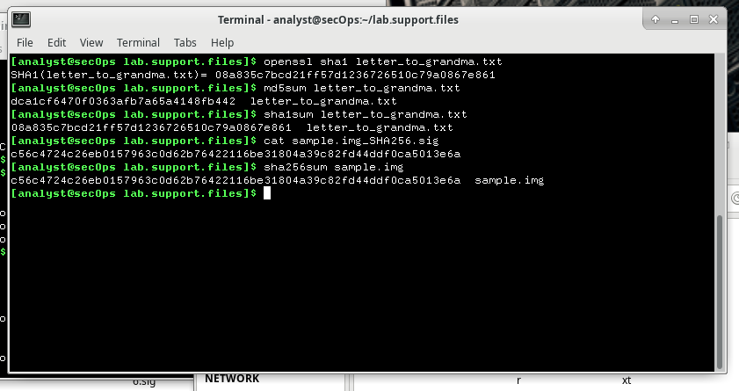

**Was the sample.img correctly downloaded? Explain.**

Yes, because hash of file and after downloading matches. It means file was downloaded without errors.